Module 2: Development
- Exploring Git and GitHub Commands, Familiarize students with essential Git concepts and commands.
- git –version
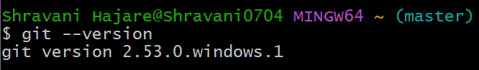
- configuring username and email
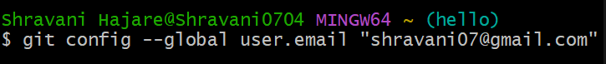
- initializing a repository
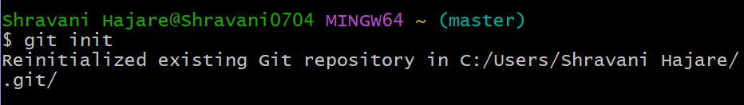
- adding files to staging area
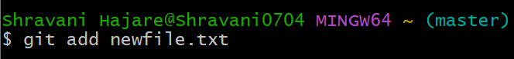
- commit files
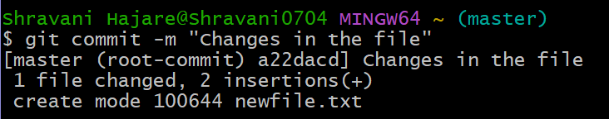
- connect to remote repository
- push code to remote repository
- git push -u origin main
- Git branch
- Add:
- Display:
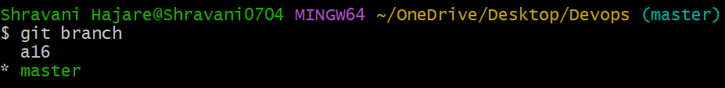
- Delete branch:
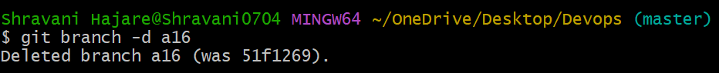
- Switch branch:
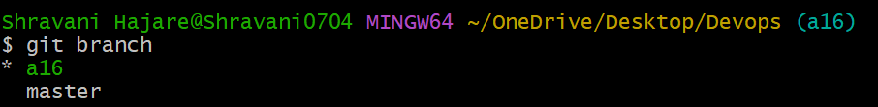
- Log:
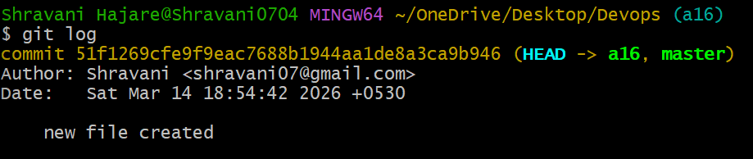

- Basic Git commands - init, clone, add, commit, push, pull.

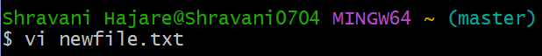
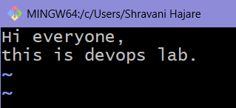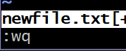
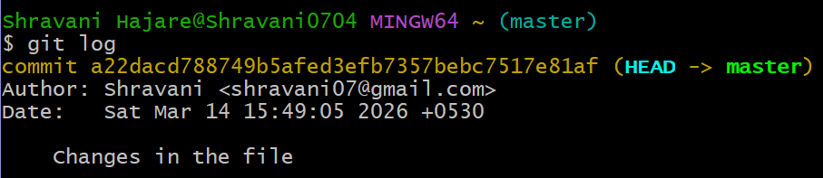
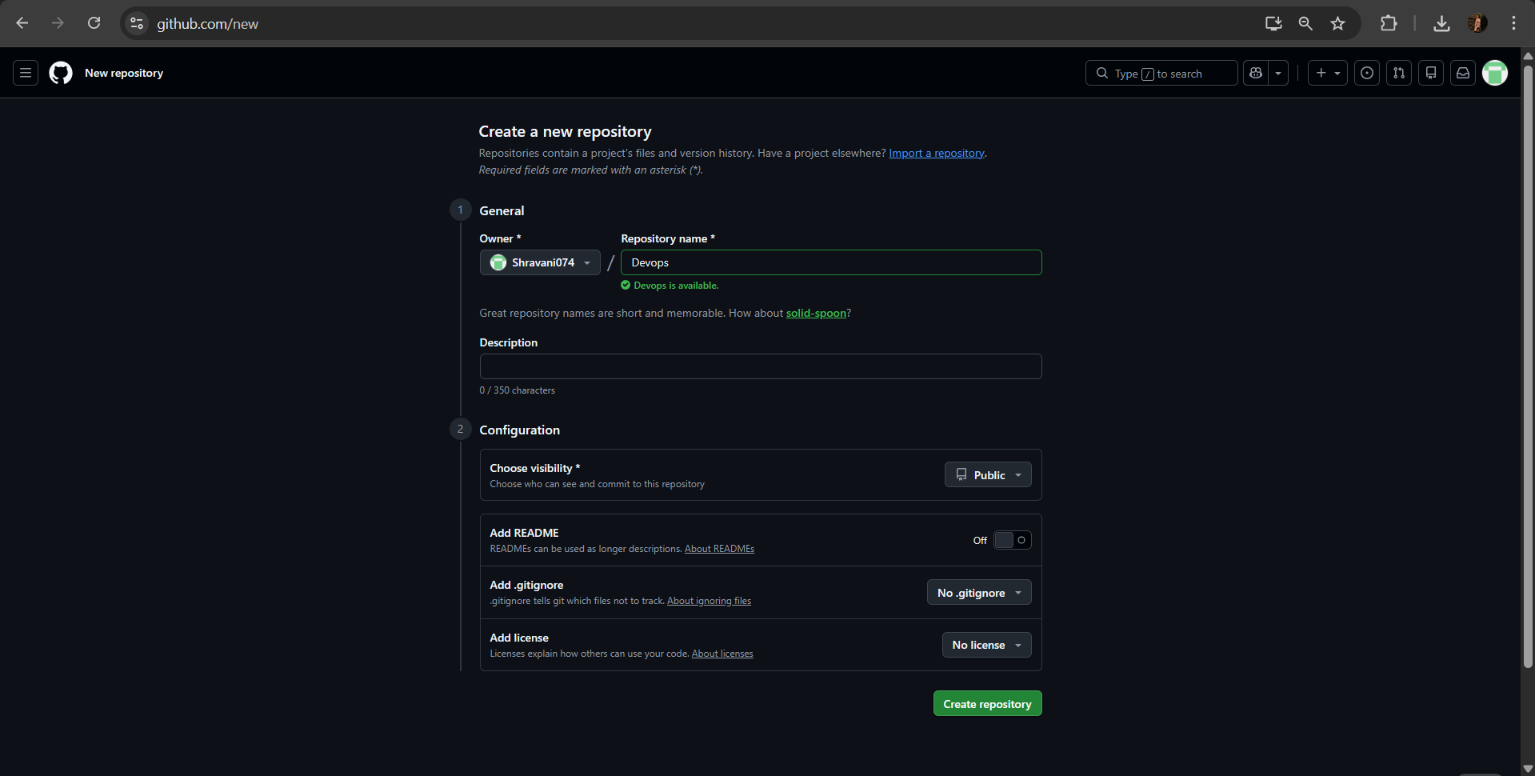
Edit README.md file
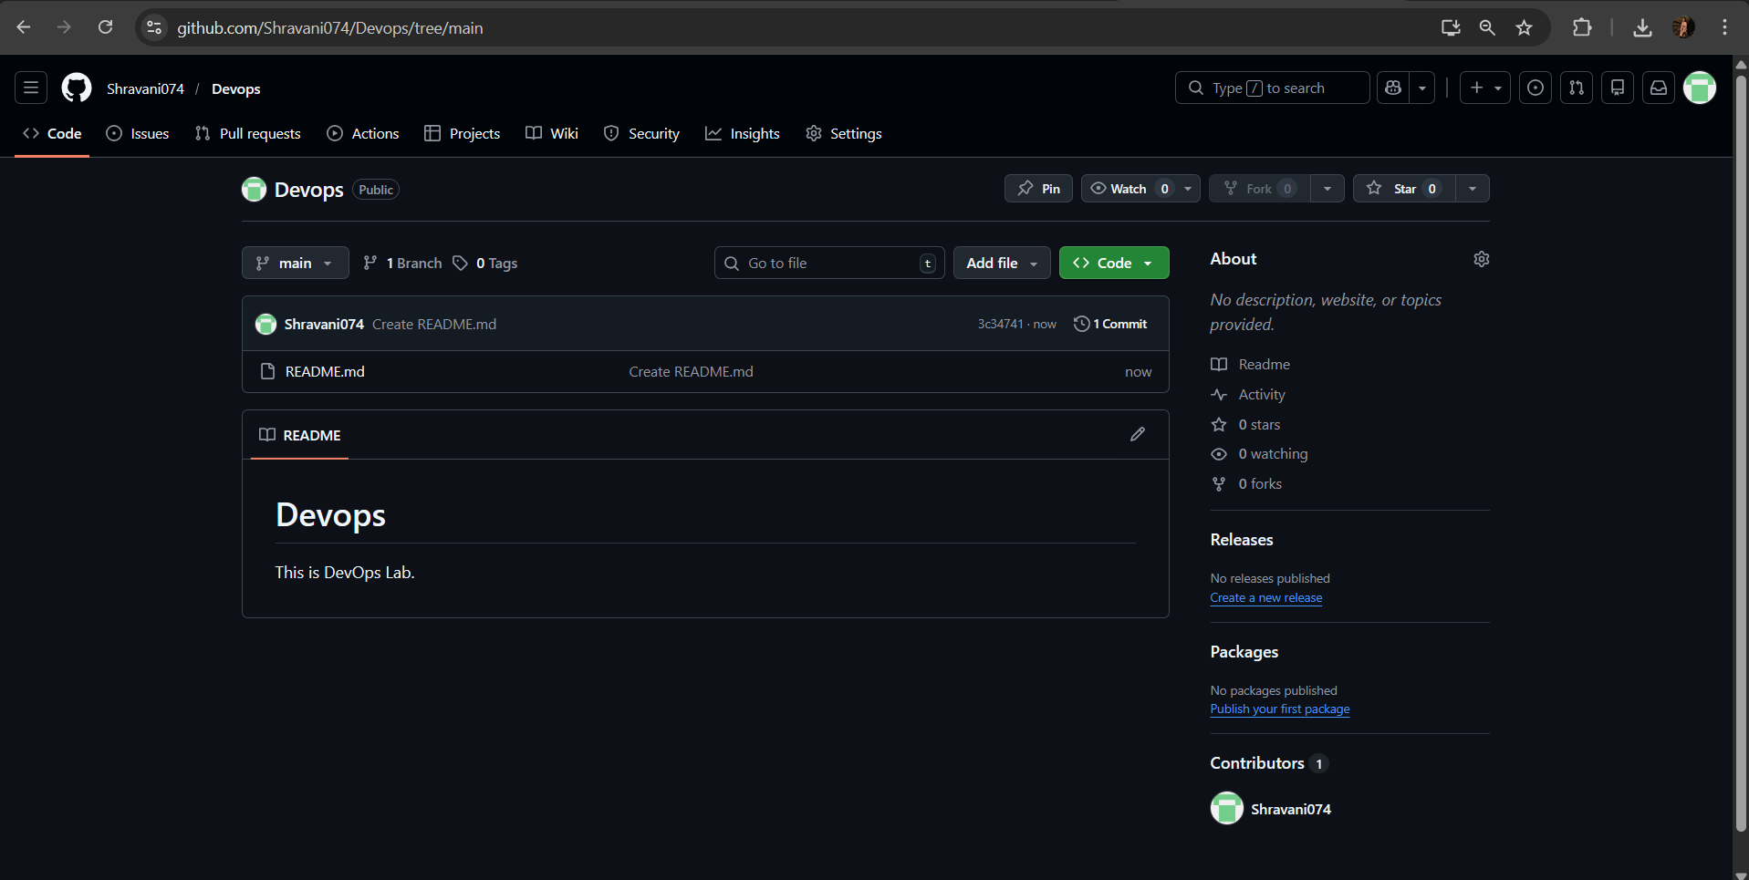
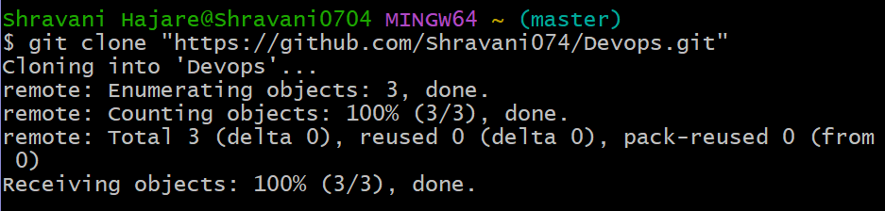
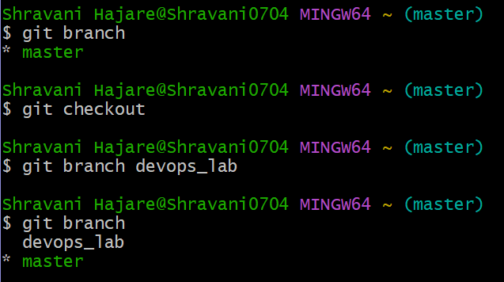
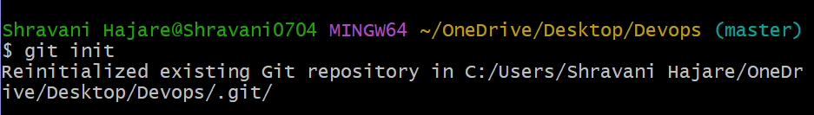
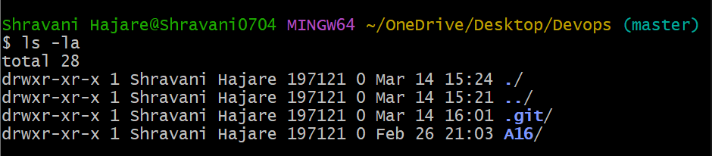
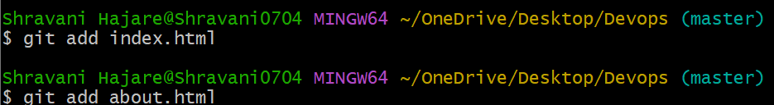
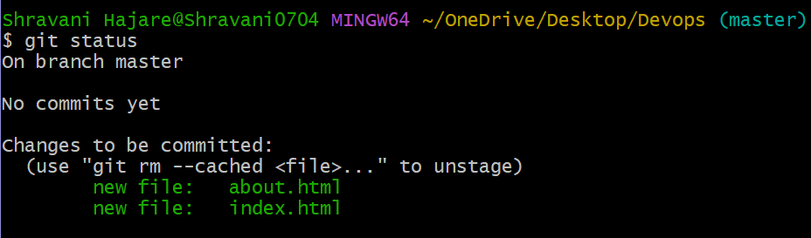
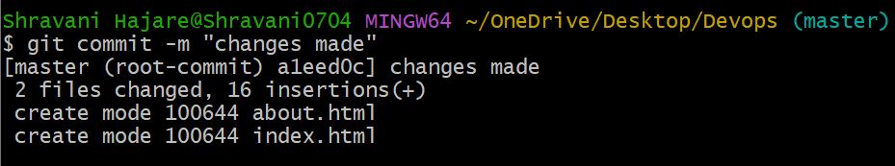
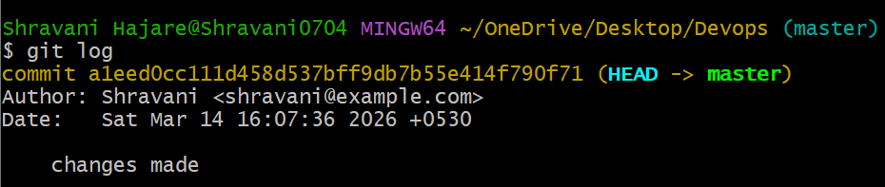
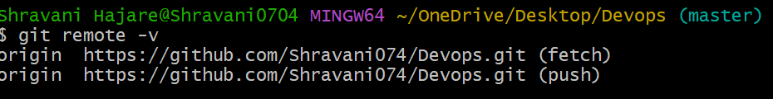
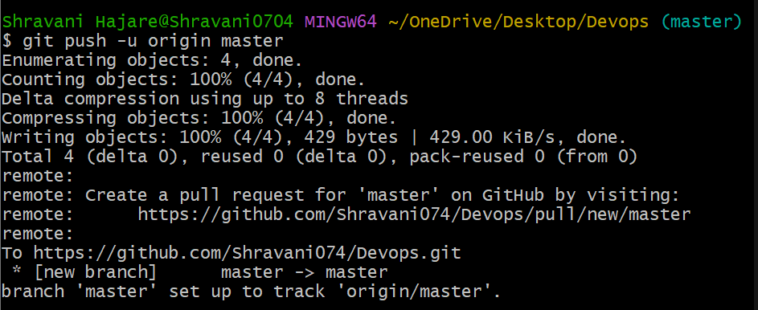

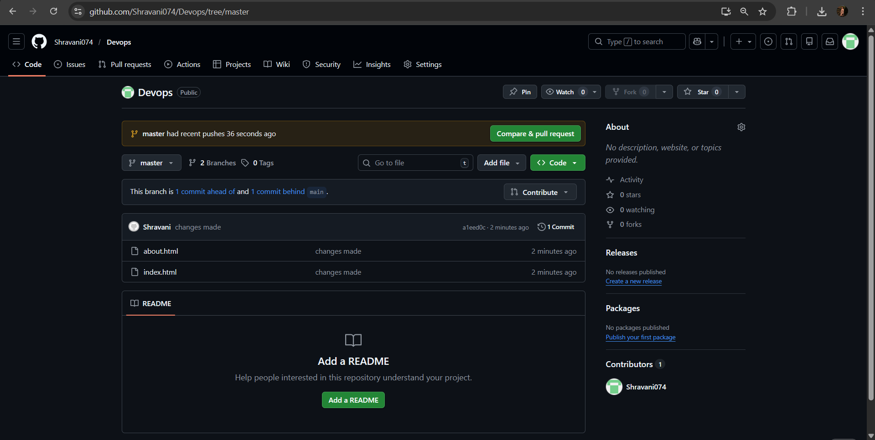
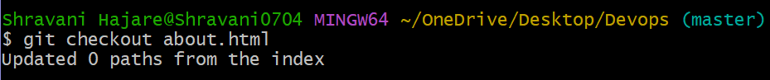
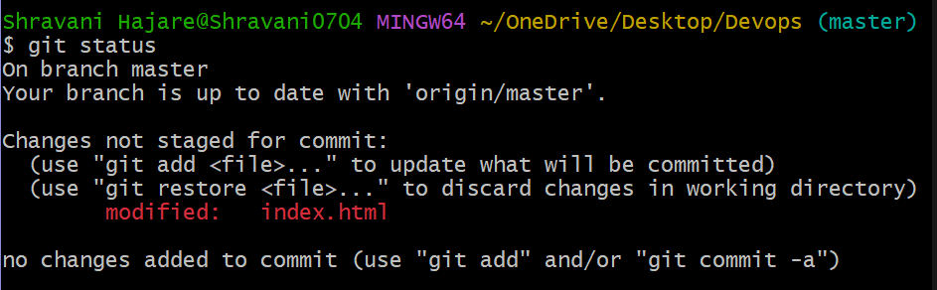
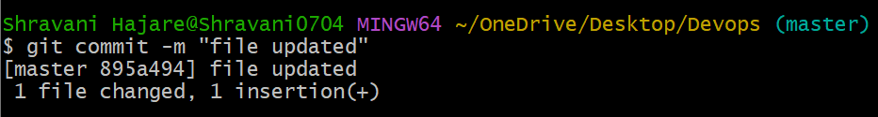
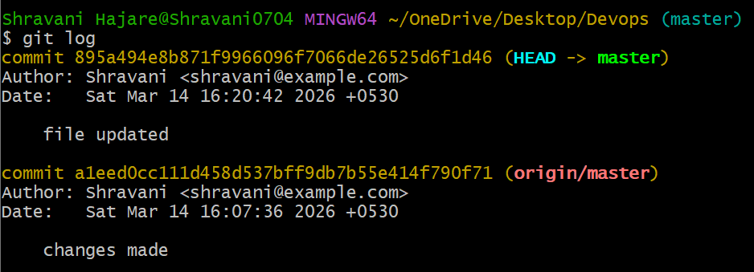
- GitHub operations using Git-forks, pull requests, merging, Git for version control
